ASSIGNMENT NO. – 4

Q1 a) Write a program to design a class Volume and then find out the volume of a cube, cylinder and ellipsoid using method overloading using BufferedReader class object.

CODE:

import java.io.*;

class Volume {

double v_(double side) {

return side * side * side;

}

double v_(double radius, double height) {

return Math.PI * radius * radius * height;

}

double v_(double a_, double b_, double c_) {

return (4 * a_ * b_ * c_)/3;

}

public static void main(String[] args)throws IOException {

BufferedReader reader = new BufferedReader(new InputStreamReader(System.in));

System.out.println("Enter the side of the Cube: ");

double s = Double.parseDouble(reader.readLine());

System.out.println("Enter the value of (a) of the Ellipsoid: ");

double a = Double.parseDouble(reader.readLine());

System.out.println("Enter the value of (b) of the Ellipsoid: ");

double b = Double.parseDouble(reader.readLine());

System.out.println("Enter the value of (c) of the Ellipsoid: ");

double c = Double.parseDouble(reader.readLine());

System.out.println("Enter the radius of the Cuboid: ");

double r = Double.parseDouble(reader.readLine());

System.out.println("Enter the height of the Cuboid: ");

double h = Double.parseDouble(reader.readLine());

Volume ob=new Volume();

double p_cu=ob.v_(s);

double p_cy=ob.v_(r,h);

double p_el=ob.v_(a,b,c);

System.out.println("Volume of the cuboid is:"+p_cu);

System.out.println("Volume of the cylinder is:"+p_cy);

System.out.println("Volume of the ellipsoid is:"+p_el);

}

}

OUTPUT

D:\User> javac Volume.java

D:\User> java Volume

Enter the side of the Cube: 4

Enter the value of (a) of the Ellipsoid: 3

Enter the value of (b) of the Ellipsoid: 5

Enter the value of (c) of the Ellipsoid: 7

Enter the radius of the Cuboid: 4

Enter the height of the Cuboid: 2

Volume of the cuboid is:64.0

Volume of the cylinder is: 100.53096491487338

Volume of the ellipsoid is:140.0

b) Write a program to design a class Volume and then find out the volume of a cube, cylinder and ellipsoid using method overloading using command line argument.

CODE:

class Volume {

double v_(double side) {

return side * side * side;

}

double v_(double radius, double height) {

return Math.PI * radius * radius * height;

}

double v_(double a_, double b_, double c_) {

return (4 * a_ * b_ * c_) / 3;

}

public static void main(String[] args) {

if (args.length != 6) {

System.out.println("Please provide exactly 6 arguments: side_of_cube, a_of_ellipsoid, b_of_ellipsoid, c_of_ellipsoid, radius_of_cylinder, height_of_cylinder");

return;

}

double s = Double.parseDouble(args[0]);

double a = Double.parseDouble(args[1]);

double b = Double.parseDouble(args[2]);

double c = Double.parseDouble(args[3]);

double r = Double.parseDouble(args[4]);

double h = Double.parseDouble(args[5]);

Volume ob = new Volume();

double p_cu = ob.v_(s);

double p_cy = ob.v_(r, h);

double p_el = ob.v_(a, b, c);

System.out.println("Volume of the cube is: " + p_cu);

System.out.println("Volume of the cylinder is: " + p_cy);

System.out.println("Volume of the ellipsoid is: " + p_el);

}

}

OUTPUT

D:\User> javac Volume.java

D:\User> java Volume4 3 5 7 4 2

Volume of the cuboid is:64.0

Volume of the cylinder is: 100.53096491487338

Volume of the ellipsoid is:140.0

Q2) Create a class named complex with data members as real and imaginary. Overload three constructors to initialize the data members (i.e. default, no parameter, parameterized and through object initialization). Provide methods which returns object of the complex class as the result for addition, subtraction and multiplication of two complex numbers.

CODE:

import java.io.*;

class complex {

double real;

double img;

complex() {

real=4.0;

img=4.0;

}

complex(double a, double b) {

real=a;

img=b;

}

complex(complex ob) {

real=ob.real;

img=ob.img;

}

complex add(complex ob1, complex ob2) {

complex ans = new complex();

ans.real = ob1.real + ob2.real;

ans.img = ob1.img + ob2.img;

return ans;

}

complex mul(complex ob1, complex ob2) {

complex ans = new complex();

ans.real = (ob1.real*ob2.real)-(ob1.img*ob2.img);

ans.img = (ob1.img*ob2.real)+(ob1.real*ob2.img);

return ans;

}

complex sub(complex ob1, complex ob2) {

complex ans = new complex();

ans.real = ob1.real - ob2.real;

ans.img = ob1.img - ob2.img;

return ans;

}

void print() {

System.out.println("Complex Number is: "+real+"+"+"("+img+")"+"i");

}

public static void main(String args[]) throws IOException {

BufferedReader br = new BufferedReader(new InputStreamReader(System.in));

System.out.println("1.No Parameter.");

System.out.println("2.With Parameter.");

System.out.println("3.With Object Initialization.");

System.out.println("Enter your choice:");

int ch = Integer.parseInt(br.readLine());

switch(ch) {

case 1:

complex o4 = new complex();

complex o5 = new complex();

complex o6 = new complex();

complex o7 = new complex();

complex o8 = new complex();

o6 = o6.add(o4, o5);

o7 = o7.sub(o4, o5);

o8 = o8.add(o4, o5);

System.out.println("For Addition:");

o6.print();

System.out.println("For Subtraction:");

o7.print();

System.out.println("For Multiplication:");

o8.print();

break;

case 2:

System.out.println("Enter the first real number:");

double r1=Double.parseDouble(br.readLine());

System.out.println("Enter the second real number:");

double r2=Double.parseDouble(br.readLine());

System.out.println("Enter the first imaginary number:");

double i1=Double.parseDouble(br.readLine());

System.out.println("Enter the second imaginary number:");

double i2=Double.parseDouble(br.readLine());

complex o1 = new complex(r1,i1);

complex o2 = new complex(r2,i2);

complex o3 = new complex();

complex o9 = new complex();

complex o10 = new complex();

o3 = o3.add(o1, o2);

o9 = o9.sub(o1, o2);

o10 = o10.mul(o1, o2);

System.out.println("For Addition:");

o3.print();

System.out.println("For Subtraction:");

o9.print();

System.out.println("For Multiplication:");

o10.print();

break;

case 3:

System.out.println("Enter the first real number:");

r1=Double.parseDouble(br.readLine());

System.out.println("Enter the second real number:");

r2=Double.parseDouble(br.readLine());

System.out.println("Enter the first imaginary number:");

i1=Double.parseDouble(br.readLine());

System.out.println("Enter the second imaginary number:");

i2=Double.parseDouble(br.readLine());

complex o11 = new complex(r1,i1);

complex o12 = new complex(r2,i2);

complex o13 = new complex(o11);

complex o14 = new complex(o12);

complex o15 = new complex();

complex o16 = new complex();

complex o17 = new complex();

o15 = o15.add(o13, o14);

o16 = o16.sub(o13, o14);

o17 = o17.mul(o13, o14);

System.out.println("For Addition:");

o15.print();

System.out.println("For Subtraction:");

o16.print();

System.out.println("For Multiplication:");

o17.print();

break;

default:

System.out.println("WRONG CHOICE!!");

}

}

}

OUTPUT

D:\User>javac complex.java

D:\User>java complex

1.No Parameter.

2.With Parameter.

3.With Object Initialization.

Enter your choice: 3

Enter the first real number: 4

Enter the second real number: 3

Enter the first imaginary number: 8

Enter the second imaginary number: 1

For Addition:

Complex Number is: 7.0+(9.0)i

For Subtraction:

Complex Number is: 1.0+(7.0)i

For Multiplication:

Complex Number is: 4.0+(28.0)i

ASSIGNMENT NO. – 5

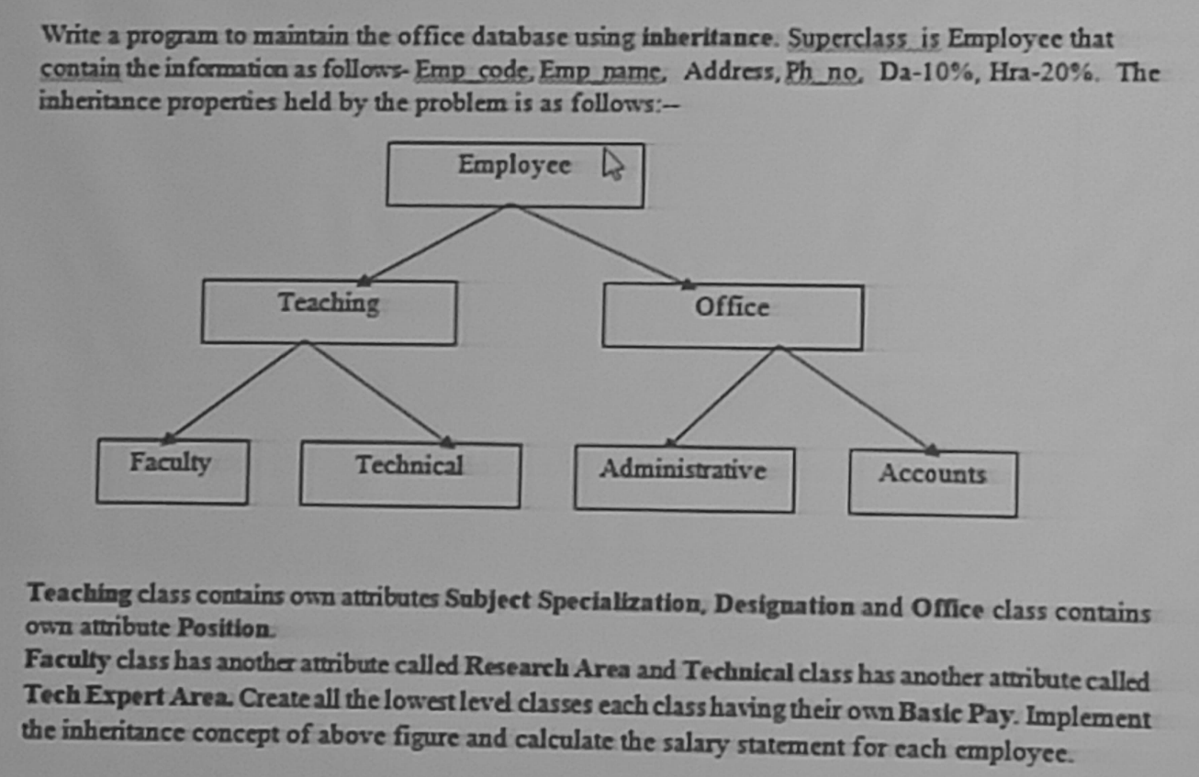

CODE:

import java.io.BufferedReader;

import java.io.InputStreamReader;

import java.io.IOException;

class Employee{

int code;

String name, ph, add;

double da=0.1, hra=0.2, bP;

Employee(int c, String n, String p, String A, double b){

code=c;

name=n;

ph=p;

add=A;

bP=b;

}

double cal_sal(){

return (bP+(bP*da)+(bP*hra));

}

void show(){

System.out.println("Code: "+code+" Name:"+name+" Phone: "+ph+" Address: "+add);

System.out.println("Basic Pay: "+bP+ "Da:"+da+" Hra: "+hra);

}

}

class Teach extends Employee{

String subSpec,design;

Teach(int c, String n, String p, String A, double b,String S, String desi){

super(c,n,p,A,b);

subSpec=S;

design=desi;

}

void show(){

super.show();

System.out.println("Subject: "+subSpec+ "Designation: "+design);

}

}

class Fac extends Teach{

String rArea;

Fac(int c, String n, String p, String A, double b,String S, String desi, String r){

super(c,n,p,A,b,S,desi);

rArea=r;

}

void show(){

super.show();

System.out.println("Research Area: "+rArea);

}

}

class Tech extends Teach{

String tExp;

Tech(int c, String n, String p, String A, double b,String S, String desi,String tec){

super(c,n,p,A,b,S,desi);

tExp=tec;

}

void show(){

super.show();

System.out.println("Tech Expert Area: "+tExp);

}

}

public class OfficeDB{

public static void main(String args[])throws IOException{

BufferedReader br=new BufferedReader(new InputStreamReader(System.in));

System.out.println("Enter Your Choice:");

System.out.println("1-Faculty");

System.out.println("2-Technical");

int ch=Integer.parseInt(br.readLine());

switch(ch){

case 1:

//Faculty

System.out.println("Enter the deatils of the faculty: ");

System.out.println("Code: ");

int fcode=Integer.parseInt(br.readLine());

System.out.println("Name: ");

String fname=br.readLine();

System.out.println("Address: ");

String fadd=br.readLine();

System.out.println("Phone Number: ");

String fph=br.readLine();

System.out.println("Basic Pay: ");

double fbp=Double.parseDouble(br.readLine());

System.out.println("Subject: ");

String fsub=br.readLine();

System.out.println("Designation: ");

String fDes=br.readLine();

System.out.println("Research Area: ");

String frAre=br.readLine();

Fac f=new Fac(fcode,fname,fadd,fph,fbp,fsub,fDes,frAre);

f.show();

System.out.println("Salary: "+f.cal_sal());

break;

case 2:

System.out.println("Enter the deatils of the Technical: ");

System.out.println("Code: ");

int tcode=Integer.parseInt(br.readLine());

System.out.println("Name: ");

String tname=br.readLine();

System.out.println("Address: ");

String tadd=br.readLine();

System.out.println("Phone Number: ");

String tph=br.readLine();

System.out.println("Basic Pay: ");

double tbp=Double.parseDouble(br.readLine());

System.out.println("Subject: ");

String tsub=br.readLine();

System.out.println("Designation: ");

String tDes=br.readLine();

System.out.println("Tech Area: ");

String tExpe=br.readLine();

Tech t=new Tech(tcode,tname,tadd,tph,tbp,tsub,tDes,tExpe);

t.show();

System.out.println("Salary: "+t.cal_sal());

break;

default:

System.out.println("Invalid choice");

}

}

}

Output:

C:\Users\student\Desktop\java>java OfficeDB

Enter Your Choice:

1-Faculty

2-Technical

1

Enter the deatils of the faculty:

Code:

12

Name:

X

Address:

ABC

Phone Number:

1234567890

Basic Pay:

4000

Subject:

Photography

Designation:

goat

Research Area:

nsec

Code: 12 Name:X Phone: 1234567890 Address:ABC

Basic Pay: 4000.0Da:0.1 Hra: 0.2

Subject: Photography Designation: goat

Research Area: nsec

Salary: 5200.0

ASSIGNMENT NO. – 6

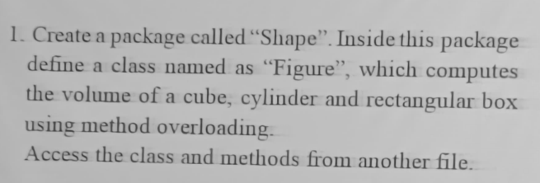

CODE:

Figure.java🡪

package colleg.d6.Shape;

public class Figure {

    public double volume(double side){

        return side*side*side;

    }

    public double volume(double height,double radius){

        return Math.PI*radius*radius*height;

    }

    public double volume(double length,double width,double height ){

        return  length*width*height;

    }

}

FigureDemo.java🡪

package colleg.d6.Shape;

import java.io.BufferedReader;

import java.io.IOException;

import java.io.InputStreamReader;

public class FigureDemo {

    public static void main(String[] args) {

        BufferedReader reader = new BufferedReader(new InputStreamReader(System.in));

        Figure fig = new Figure();

        try {

            System.out.println("Enter the shape (Cuboid, Cylinder, Cube): ");

            String choice = reader.readLine(); // Reading the shape choice

while(true) {

    switch (choice) {

        case "Cuboid":

            System.out.println("Enter length, width, and height of the cuboid: ");

            double length = Double.parseDouble(reader.readLine());

            double width = Double.parseDouble(reader.readLine());

            double height = Double.parseDouble(reader.readLine());

            System.out.println("The volume of the cuboid is: " + fig.volume(length, width, height));

            break;

        case "Cylinder":

            System.out.println("Enter radius and height of the cylinder: ");

            double radius = Double.parseDouble(reader.readLine());

            height = Double.parseDouble(reader.readLine());

            System.out.println("The volume of the cylinder is: " + fig.volume(height, radius));

            break;

        case "Cube":

            System.out.println("Enter the side of the cube: ");

            double side = Double.parseDouble(reader.readLine());

            System.out.println("The volume of the cube is: " + fig.volume(side));

            break;

        default:

            System.out.println("Invalid shape choice!");

    }

}

        } catch (IOException e) {

            System.out.println("An error occurred during input: " + e.getMessage());

        } catch (NumberFormatException e) {

            System.out.println("Invalid number format: " + e.getMessage());

        }

    }

}

OUTPUT:

Enter the shape (Cuboid, Cylinder, Cube):

Cuboid

Enter length, width, and height of the cuboid:

2

3

4

The volume of the cuboid is: 24.0

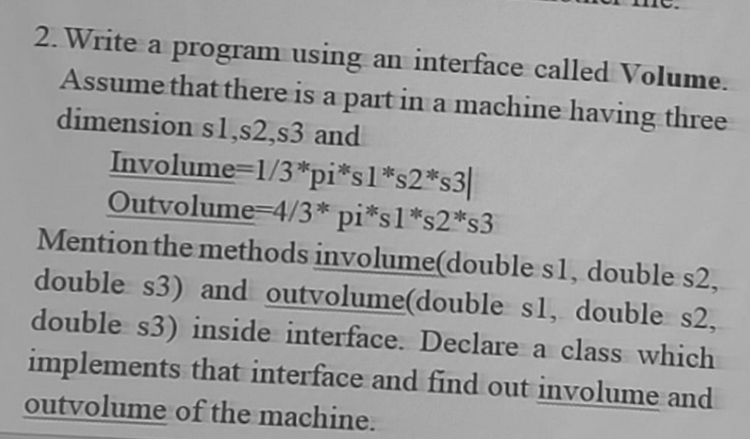

CODE:

package colleg.d6.Shape;

import java.io.BufferedReader;

import java.io.InputStreamReader;

import java.io.IOException;

interface Volume {

    public double inVolume(double s1, double s2, double s3);

    public double outVolume(double s1, double s2, double s3);

}

public class VolumeDemo implements Volume {

    @Override

    public double inVolume(double s1, double s2, double s3) {

        return (1.0 / 3) * Math.PI * s1 * s2 * s3;

    }

    @Override

    public double outVolume(double s1, double s2, double s3) {

        return (4.0 / 3) * Math.PI * s1 * s2 * s3;

    }

    public static void main(String[] args) {

        BufferedReader bf = new BufferedReader(new InputStreamReader(System.in));

        VolumeDemo demo = new VolumeDemo();

        try {

            System.out.println("Enter s1 (for base radius or radius of a sphere): ");

            double s1 = Double.parseDouble(bf.readLine());

            System.out.println("Enter s2 (for base radius or radius of a sphere): ");

            double s2 = Double.parseDouble(bf.readLine());

            System.out.println("Enter s3 (for height or radius of a sphere): ");

            double s3 = Double.parseDouble(bf.readLine());

            System.out.println("Choose volume calculation type: 'in' for inVolume, 'out' for outVolume");

            String choice = bf.readLine();

            if ("in".equalsIgnoreCase(choice)) {

                System.out.println("The calculated inVolume is: " + demo.inVolume(s1, s2, s3));

            } else if ("out".equalsIgnoreCase(choice)) {

                System.out.println("The calculated outVolume is: " + demo.outVolume(s1, s2, s3));

            } else {

                System.out.println("Invalid choice");

            }

        } catch (IOException e) {

            System.out.println("An error occurred while reading input: " + e.getMessage());

        } catch (NumberFormatException e) {

            System.out.println("Invalid number format: " + e.getMessage());

        }

    }

}

OUTPUT:

Enter s1 (for base radius or radius of a sphere):

5

Enter s2 (for base radius or radius of a sphere):

3

Enter s3 (for height or radius of a sphere):

1

Choose volume calculation type: 'in' for inVolume, 'out' for outVolume

in

The calculated inVolume is: 15.707963267948964

ASSIGNMENT NO. – 7

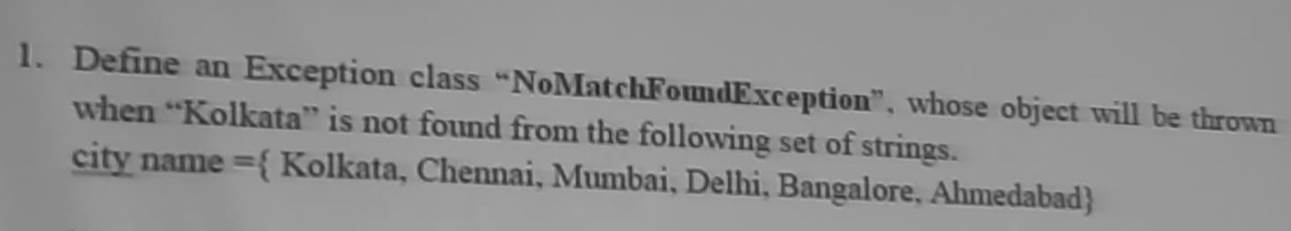

CODE:

package colleg.d7;

import java.util.Scanner;

class NoMatchFoundException extends Exception {

    public NoMatchFoundException(String message) {

        super(message);

    }

}

public class CityDemo {

    public void searchCity(String[] cities, String searchCity) throws NoMatchFoundException {

        boolean found = false;

        for (String city : cities) {

            if (city.equalsIgnoreCase(searchCity)) {

                found = true;

                break;

            }

        }

        if (!found) {

            throw new NoMatchFoundException("City '" + searchCity + "' not found in the list.");

        }

        System.out.println("City found: " + searchCity);

    }

    public static void main(String[] args) {

        Scanner sc = new Scanner(System.in);

        System.out.print("Enter the number of cities: ");

        int numberOfCities = sc.nextInt();

        sc.nextLine();

        String[] cities = new String[numberOfCities];

        for (int i = 0; i < numberOfCities; i++) {

            System.out.print("Enter city " + (i + 1) + ": ");

            cities[i] = sc.nextLine();

        }

        System.out.print("Enter the city name to search: ");

        String searchCity = sc.nextLine();

        CityDemo cityDemo = new CityDemo();

        try {

            cityDemo.searchCity(cities, searchCity);

        } catch (NoMatchFoundException e) {

            System.out.println(e.getMessage());

        }

    }

}

OUTPUT:

Enter the number of cities: 3

Enter city 1: ahmedabad

Enter city 2: delhi

Enter city 3: mumbai

Enter the city name to search: kolkata

City 'kolkata' not found in the list.

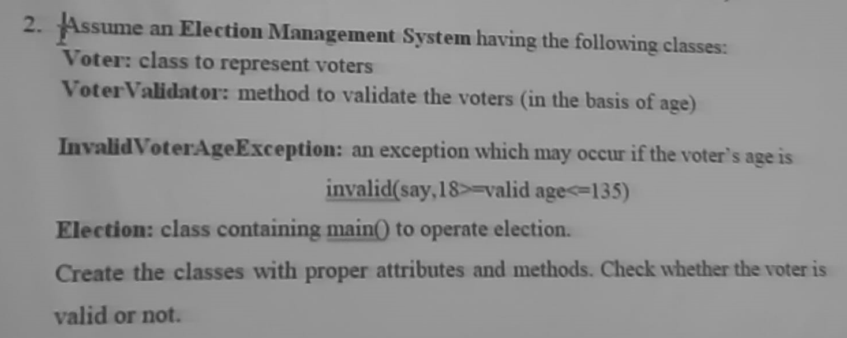

CODE:

Voter.java🡪

package colleg.d7.election;

public class Voter {

    private String name;

    private int age;

    public Voter(String name, int age) {

        this.name = name;

        this.age = age;

    }

    public String getName() {

        return name;

    }

    public int getAge() {

        return age;

    }

}

class VoterValidator {

    public static void validate(Voter voter) throws InvalidVoterAgeException {

        if (voter.getAge() < 18 || voter.getAge() > 135) {

            throw new InvalidVoterAgeException("Invalid age for voter: " + voter.getName() + ". Age must be between 18 and 135.");

        }

    }

}

class InvalidVoterAgeException extends Exception {

    public InvalidVoterAgeException(String message) {

        super(message);

    }

}

Election.java🡪

package colleg.d7.election;

import java.io.BufferedReader;

import java.io.IOException;

import java.io.InputStreamReader;

public class Election {

    public static void main(String[] args) {

        BufferedReader bf = new BufferedReader(new InputStreamReader(System.in));

        while (true) {

            try {

                System.out.print("Enter Voter's Name (or type 'exit' to stop): ");

                String name = bf.readLine();

                if (name.equalsIgnoreCase("exit")) {

                    break;

                }

                System.out.print("Enter Voter's Age: ");

                int age = Integer.parseInt(bf.readLine());

                Voter voter = new Voter(name, age);

                VoterValidator.validate(voter);

                System.out.println(voter.getName() + " is eligible to vote.");

            } catch (InvalidVoterAgeException e) {

                System.out.println(e.getMessage());

            }  catch (IOException e) {

                System.out.println("An error occurred while reading input.");

            }

        }

    }

}

OUTPUT:

Enter Voter's Name (or type 'exit' to stop): xyz

Enter Voter's Age: 23

xyz is eligible to vote.

Enter Voter's Name (or type 'exit' to stop): ab

Enter Voter's Age: 12

Invalid age for voter: ab. Age must be between 18 and 135.